

|  |
| --- |
|  |
| EBOOK |
| 2nd STatus Report |

SIR FARAZ INAM | MISS TEHREEM FATIMA

|  |  |  |  |  |  |  |  |  |  |  |
| --- | --- | --- | --- | --- | --- | --- | --- | --- | --- | --- |
| |  |  | | --- | --- | | Enrollment ID | Student Name | | Student1537282 | MUHAMMAD AHSAN | | Student1489529 | MUHAMMAD SHAHBAZ KAMAL | | Student1539346 | FARHAL ABBAS | | Student1534459 | MUHAMMAD AHMED KAMAL | |
| SIR ALI IMRAN HUSSAIN | MISS SANA YOUSUF | |



|  |  |
| --- | --- |
|  | Decorative |
| BACKGROUND |
| Our client is a famous publisher who publishes books of different categories like comics, novels, story books, General knowledge books, quiz books, journals, etc….. As there is no end for knowledge, which keeps on changing from day to day, the books are needed to be revised for every now and then. As well the stories which keep on coming as there are several writers in the world. And as there are so many publications as such and keep increasing day by day, there by increasing the competition in providing the new information, and to be first to reach out to customers. He also conducts competition for the readers by asking them to send the stories and out of the received stories the best one will be published in the next journal and as well the price will be given to the customers |

|  |  |
| --- | --- |
|  | Decorative |
| WORKDONE |
| Overview of Progress The Ebook project has successfully transitioned its core design from a static HTML template to a dynamic and scalable PHP-based platform. This foundational step has enabled seamless integration with backend operations, laying the groundwork for a functional and interactive system. The transition ensures better maintainability and dynamic content rendering for future enhancements.  **Current Functionalities Implemented** Significant progress has been made in building the administrative functionalities of the platform. A robust admin panel with login authentication has been developed, ensuring secure access to administrative operations. Additionally, CRUD (Create, Read, Update, Delete) functionality for managing admin users is fully implemented, providing control and flexibility in managing the system's backend users.   Advanced Features Added Extending beyond administrative capabilities, CRUD operations have also been established for the Author, Category, and Book tables. These features enable streamlined management of ebook records, categories, and associated authors. This functionality ensures the platform is prepared for efficient data handling and operational scalability as the database grows. |

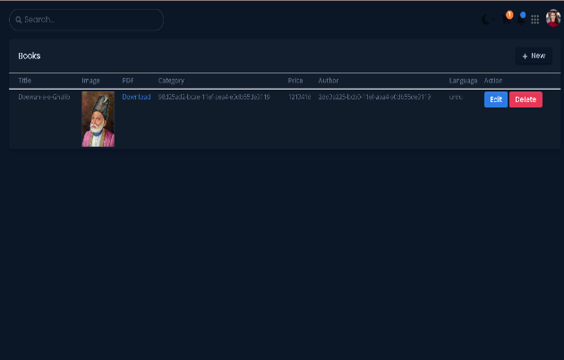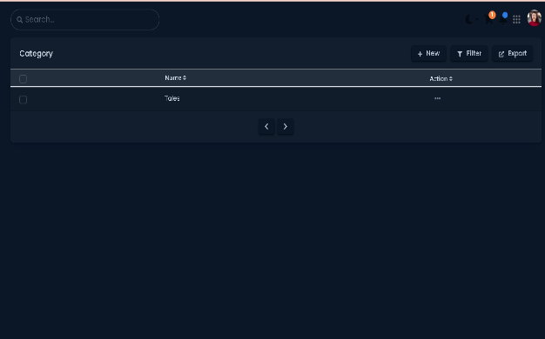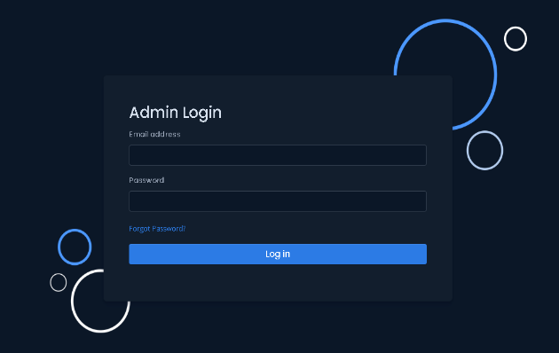

Book CRUD

Category CRUD

Admin Login